Triage bands

Triage bands are colour coded ‘slap-bands’ that are carried within the lifeboat kits to be used in conjunction with the Triage card within the Casualty Care check cards as shown.

Triage is put into effect when an incident with more casualties than rescuers presents. Both lifeboat crew and lifeguards use the card and system, (lifeguards label patients by writing the priority code on the patient’s forehead clearly with a chinagraph).

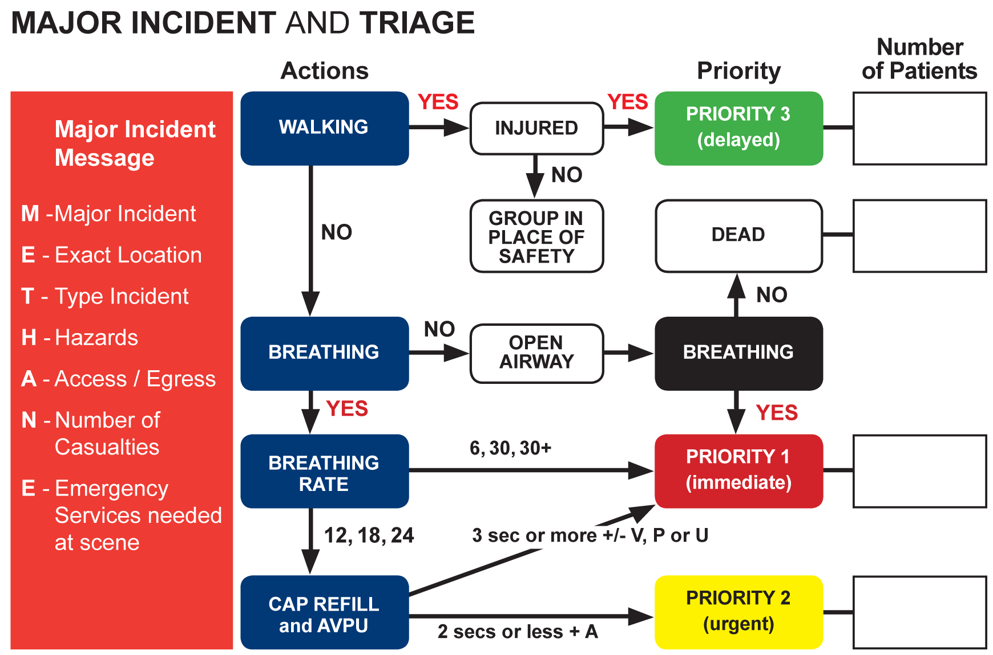

The METHANE message in red on the left hand side of the card is only to be used if the emergency services ask you for a METHANE message in relation to a Major Incident.

